ACTIVITY 1 COMPLETE : DO X DOES

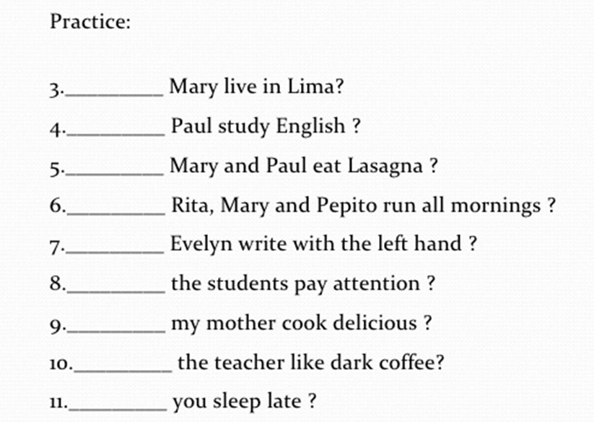

|  |
| --- |
| 3. Does |
| 4. Do |
| 5. DO |
| 6. Does |
| 7. Does |
| 8. Do |
| 9. Do |

ACTIVITY 2 ANSWER THE QUESTIONS

|  |
| --- |
| 3+ YES, SHE DOES. |
| 4 NO, HE DOESN’T. |
| 5+ YES, THEY DO |
| 6 NO, THEY DON’T |
| 7+ YES, SHE DOES |
| 8 NO, THEY DON’T |
| 9+ YES, SHE DOES |
| 10 NO, SHE DOESN’T |
| 11+ YES, I DO |
| 12 NO, THEY DON’T |

**SIMPLE VERB TENSES**

Tela de celular com publicação numa rede social

Descrição gerada com alta confiança

|  |  |  |
| --- | --- | --- |
| **IN THE MORNING** | **IN THE AFTERNOON** | **IN THE EVENING** |
| **WAKES UP AT 6 A.M** | **DOES THE HOMEWORK** | **HAS DINNER** |
| **TAKES A SHOWER** | **WATCHES TV AT 5 P.M** | **GOES TO BED AT 10 P.M** |
| **GETS DRESSED** | **PLAYS VIDEOS GAMES** |  |
| **HAS BREAKFAST** |  |  |
| **DOESN’T TAKE THE BUS** |  |  |
| **WAKES TO SCHOOL** |  |  |

Uma imagem contendo foto, mulher, pessoas

Descrição gerada com muito alta confiança

|  |
| --- |
| 1. THE BABY TAKES A SHOWER. |
| 1. THE GIRL CATCHES THE BUS TO SCHOOL. |
| 1. DAD GETS DRESSED TO WORK. |
| 1. THEY HAVE/EAT BREAKFAST WITH THE FAMILY.   HE HAS/EATS BREAKFAST WITH THE FAMILY. |
| 1. MY SISTER COMBS HER HAIR.   MY SISTER COMBS MY HAIR. |
| 1. HE KISSES MY MOM GOOD-BYE. |

Tela de celular com publicação numa rede social

Descrição gerada com alta confiança

|  |
| --- |
| 1. GETS UP |
| 1. TAKES |
| 1. GOES |
| 1. WORKS |
| 1. HAS |
| 1. SINGS |
| 1. FINISHES |
| 1. GOES |
| 1. GETS |
| 1. COOKS |
| 1. WATCHES |
| 1. READS |
| 1. GOES |